🏢 Employee Management Web Application
A simple web app to manage employee records — add, view, update salaries, and delete employees. Built with Spring Boot and MySQL, with a browser-based interface.

1. Setup
You need: Java 17, Maven, and MySQL running on your machine.
Step 1 — Open src/main/resources/application.properties and update the password:
spring.datasource.password=YOUR_MYSQL_PASSWORD
Step 2 — Start the app:
.\mvnw.cmd spring-boot:run
Step 3 — Open your browser and go to:
http://localhost:8080
Note: The database and table are created automatically on first run. No manual SQL needed.

2. Logging In
When you open the app you'll land on the login page.
Username | Password | What they can do
admin | admin123 | Everything — view, add, raise, delete
user | user123 | View employees only
Enter your credentials and click Sign In.
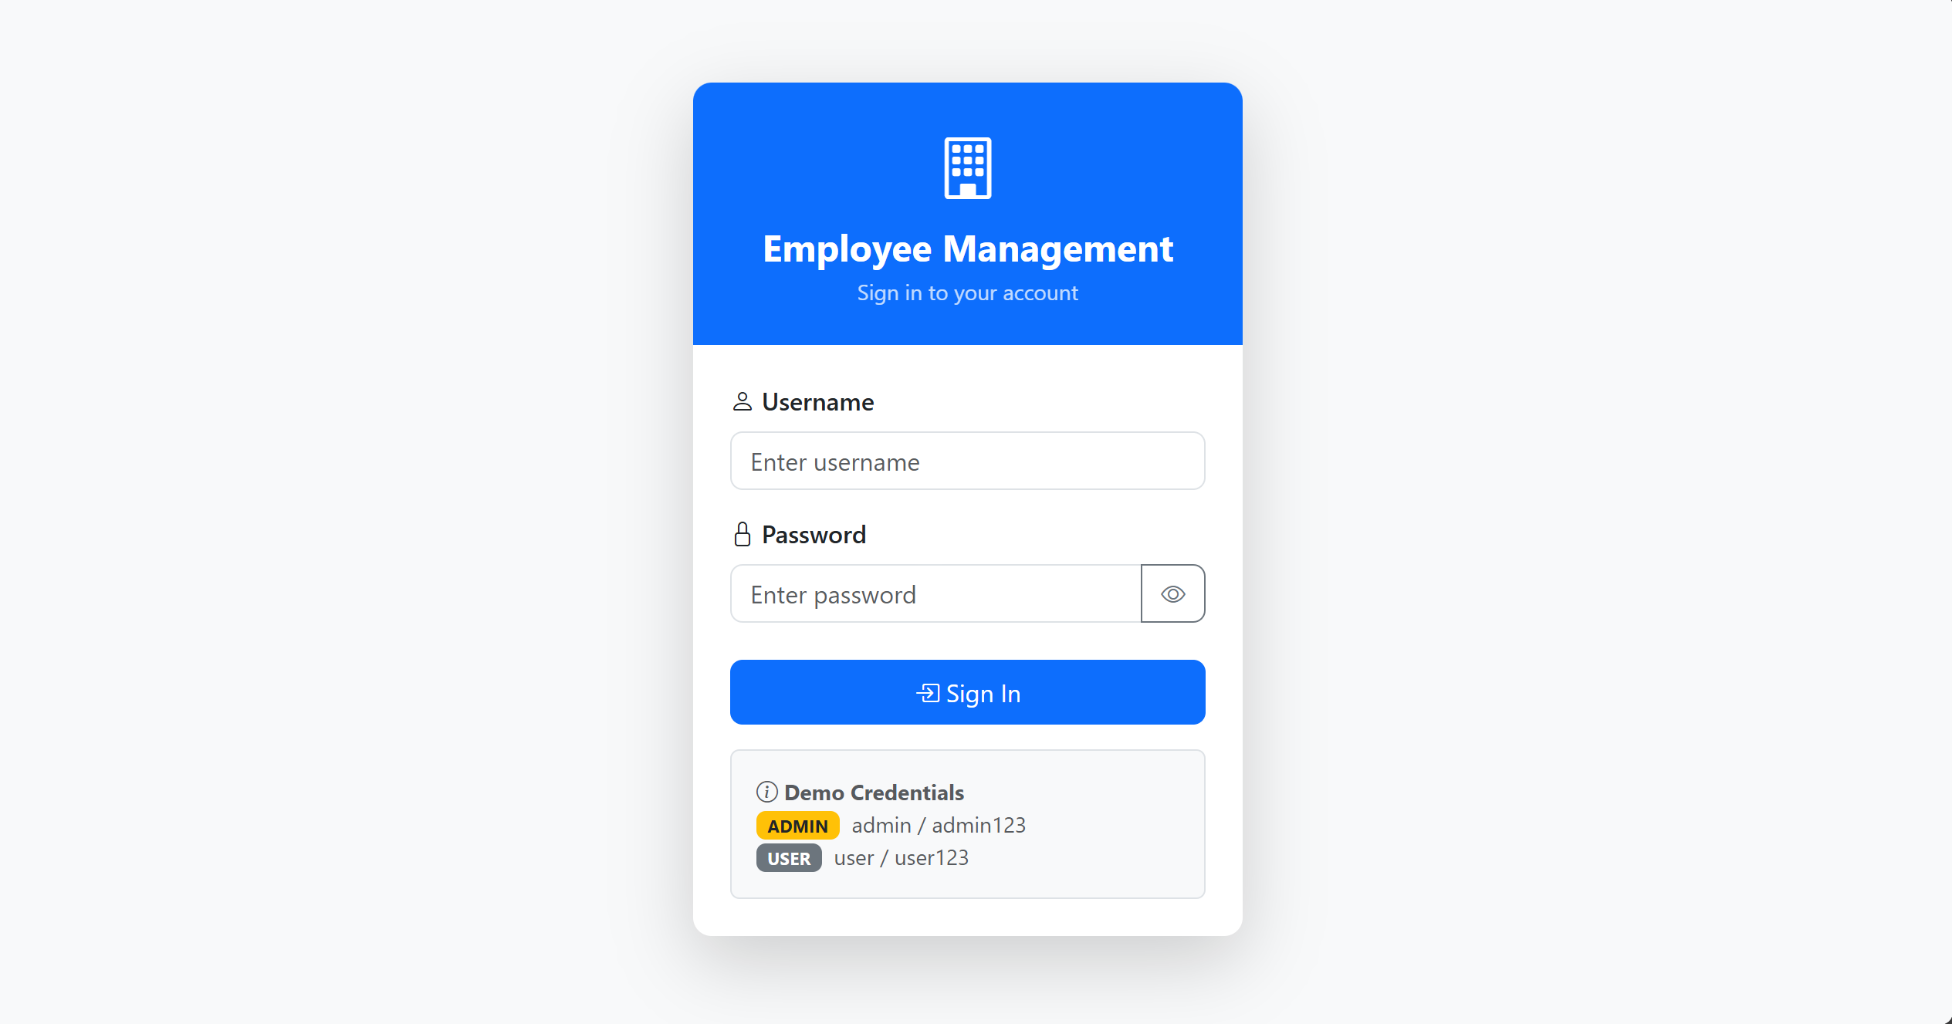If you enter wrong credentials, a red message appears and you stay on the login page.
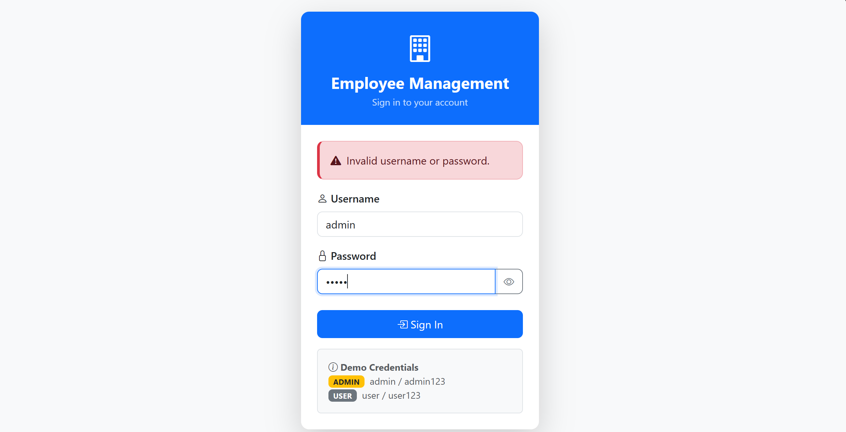
3. Dashboard
After logging in you land on the dashboard. It shows:
- How many employees are in the system
- Your username and role
- Quick-access cards for each feature
Admin sees cards for View, Add, Raise Salary, and Delete. User only sees the View card.
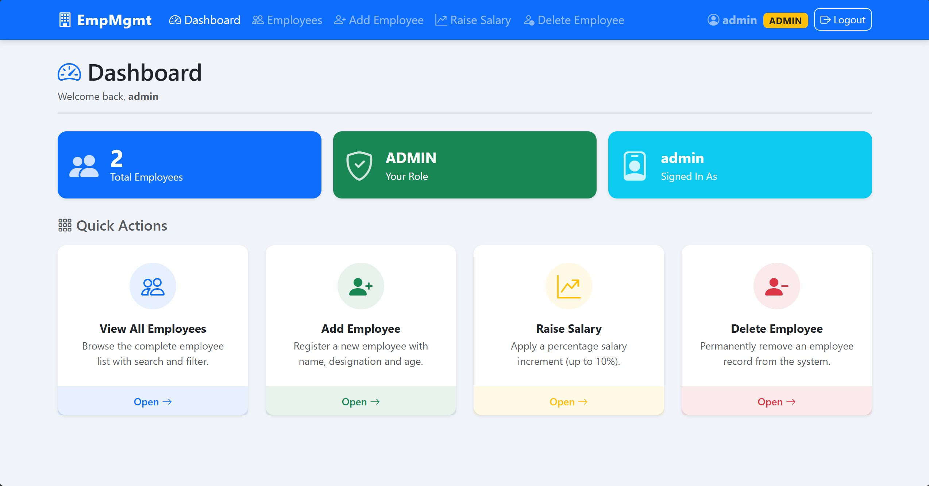
Admin Login
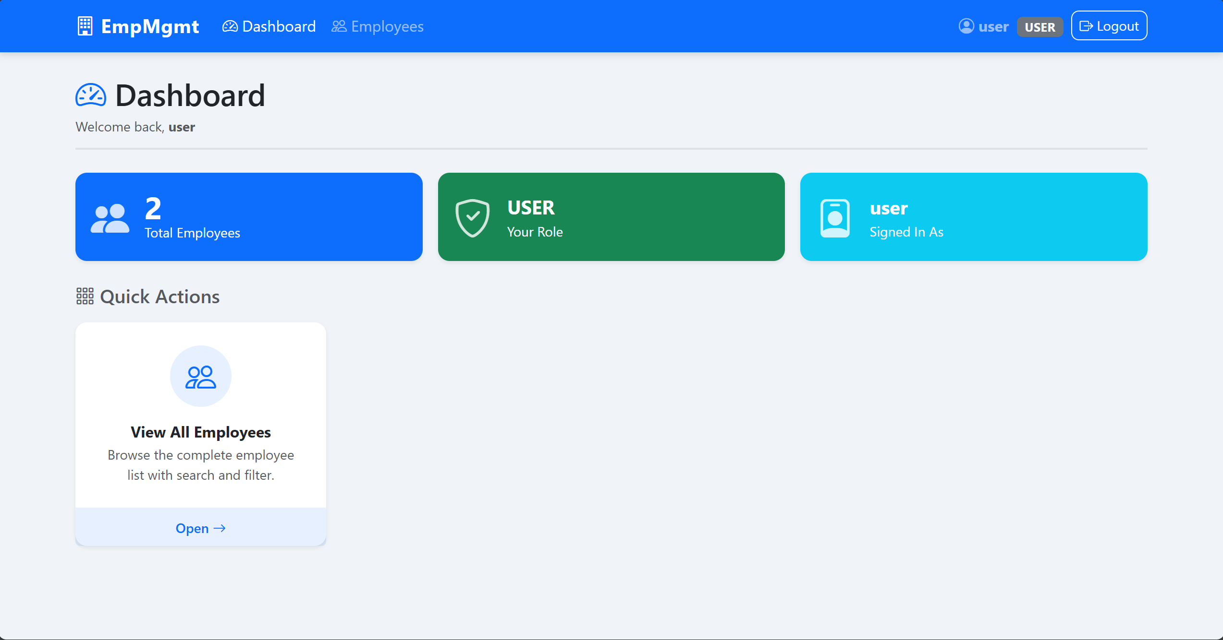
User Login

4. Viewing Employees
Click Employees in the navbar or the View card on the dashboard. You'll see a table of all employees with their ID, name, designation, age, and salary.
To filter the list:
- Type a name in the search box to find employees by name.
- Use the dropdown to show only Programmers, Testers, or Managers.
- Click Refresh to reload the latest data from the server.
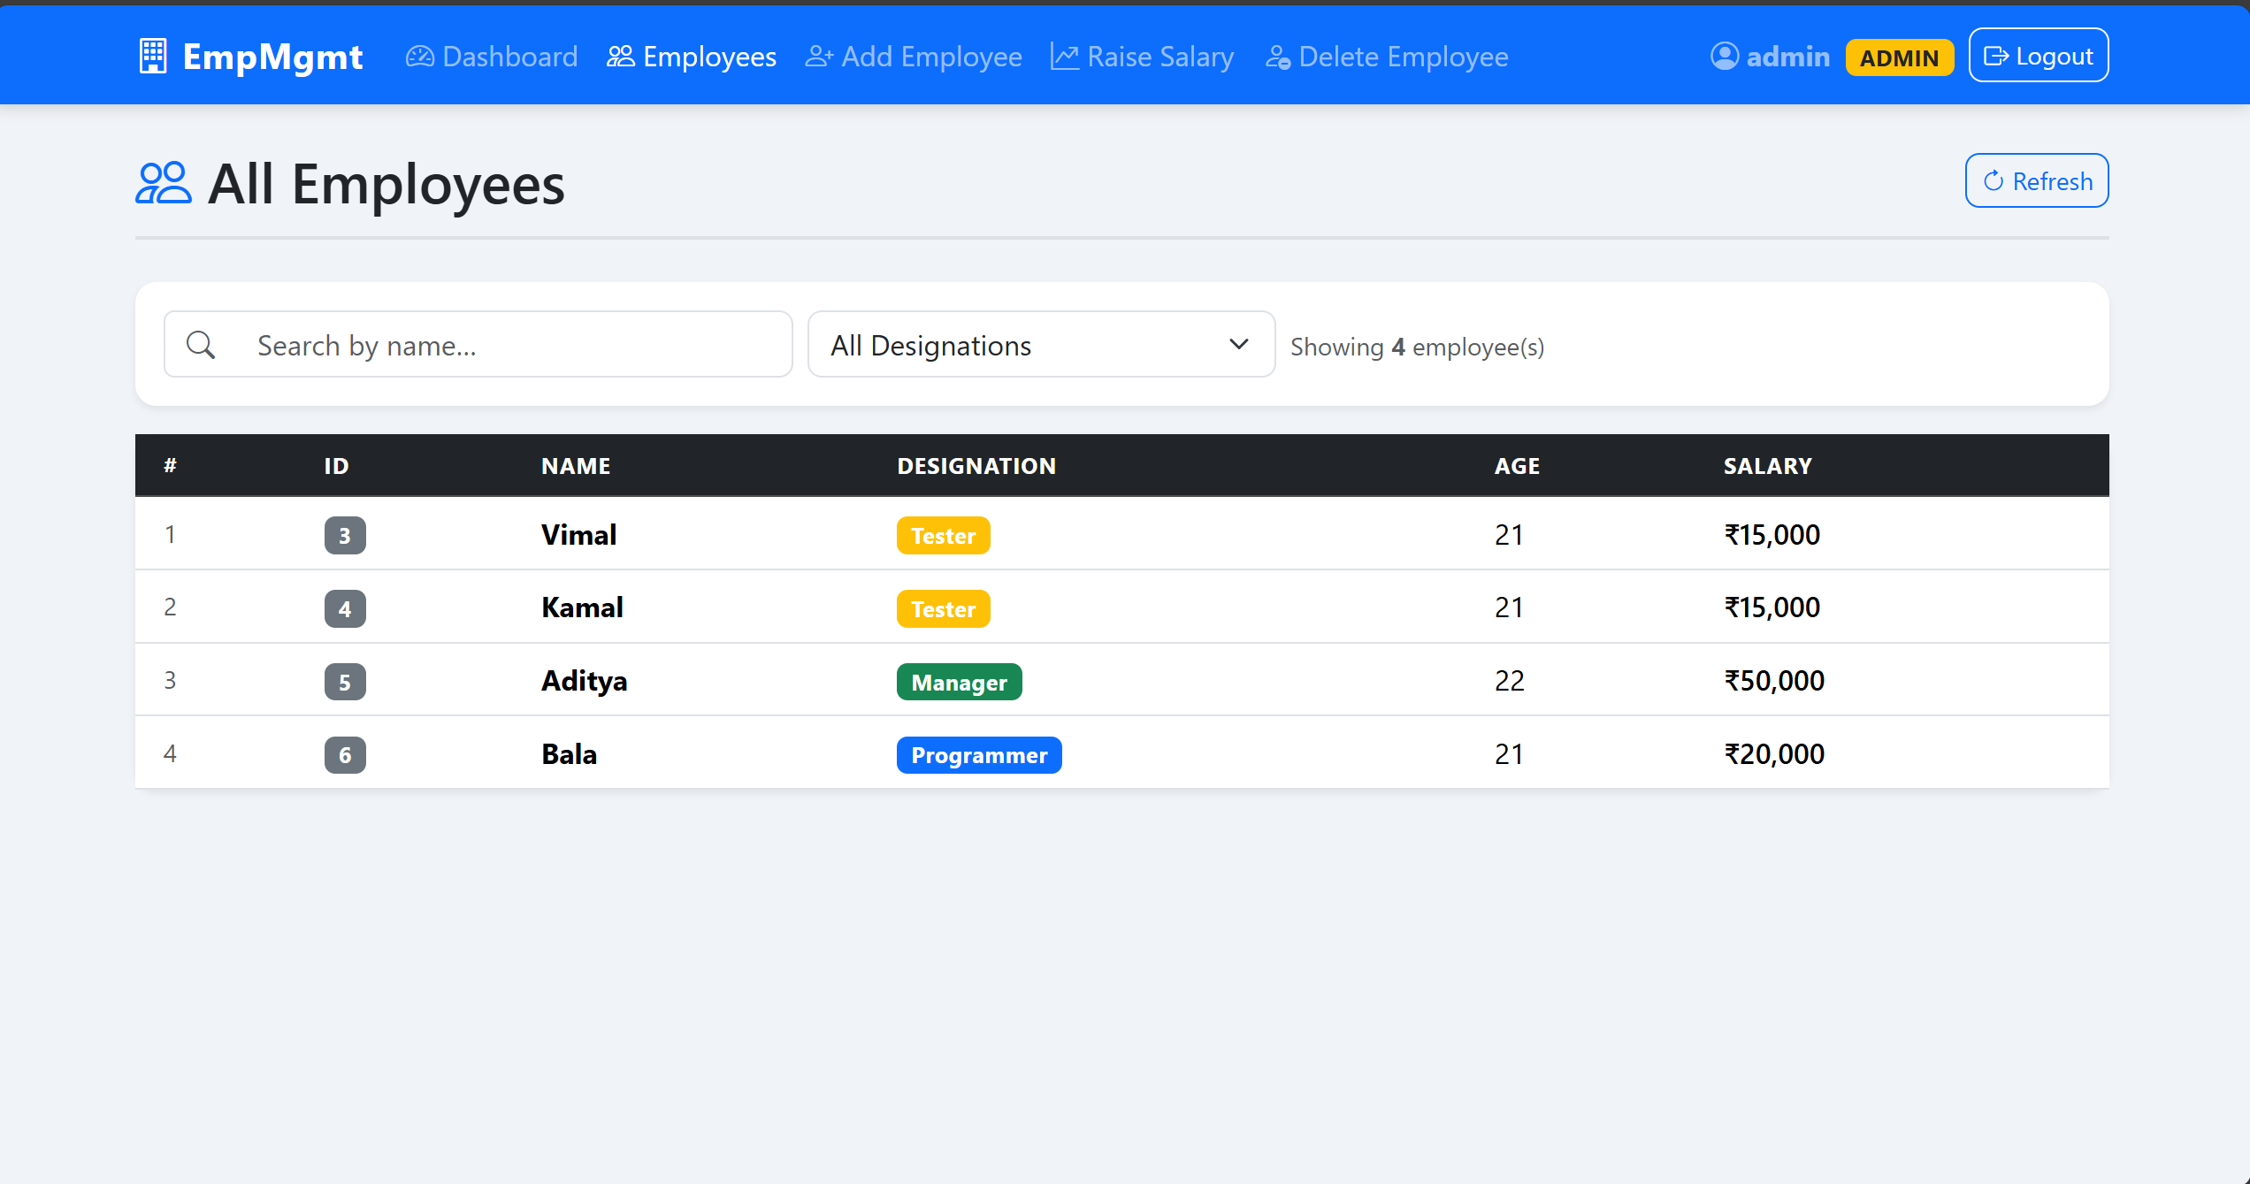EMPLOYEES TABLE WITH DATA
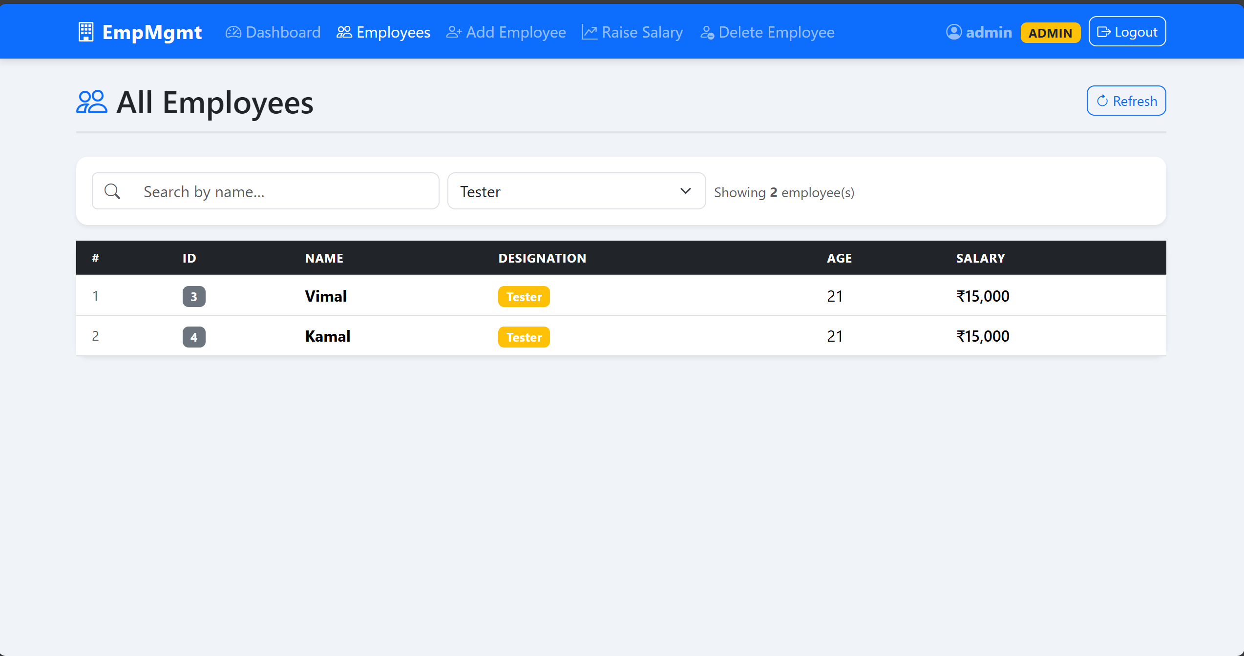EMPLOYEES TABLE WITH A FILTER APPLIED

5. Adding an Employee (🔒 Admin only)
Click Add Employee in the navbar or dashboard.
Fill in:
- Full Name — e.g. John Doe (max 3 words)
- Designation — choose from Programmer, Tester, or Manager
- Age — must be between 19 and 60
Click Add Employee. The salary is set automatically by the system — you don't enter it.
Designation | Salary assigned
Programmer | ₹ 20,000
Tester | ₹ 15,000
Manager | ₹ 50,000
On success you'll see: "Employee added successfully"
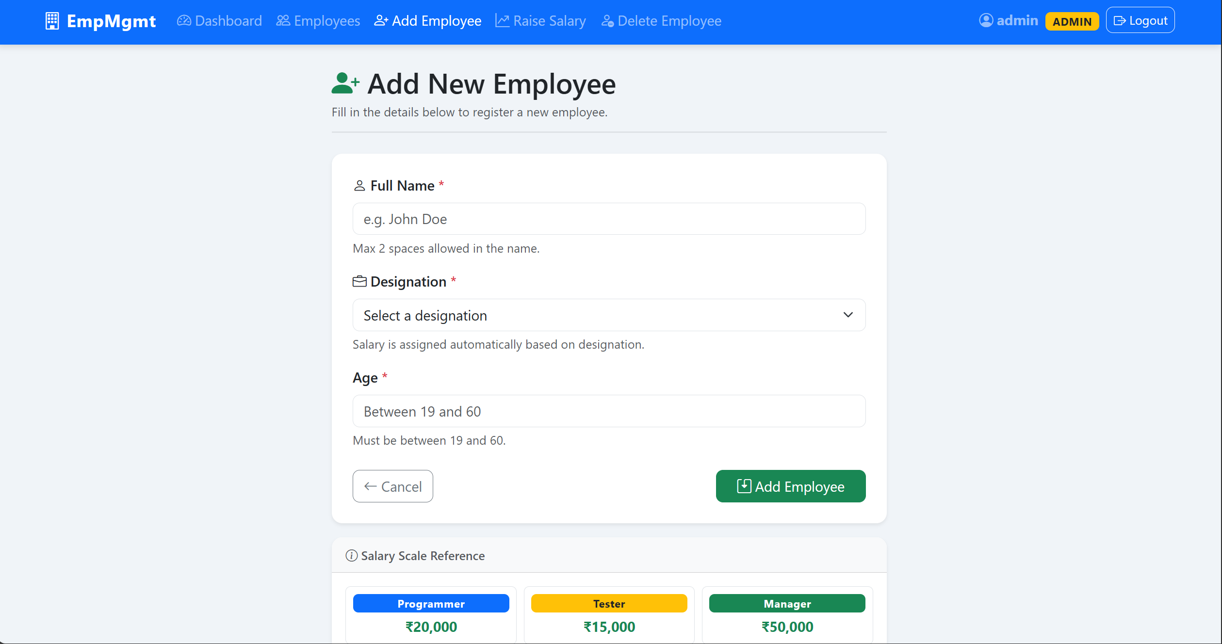
ADD EMPLOYEE FORM FILLED IN
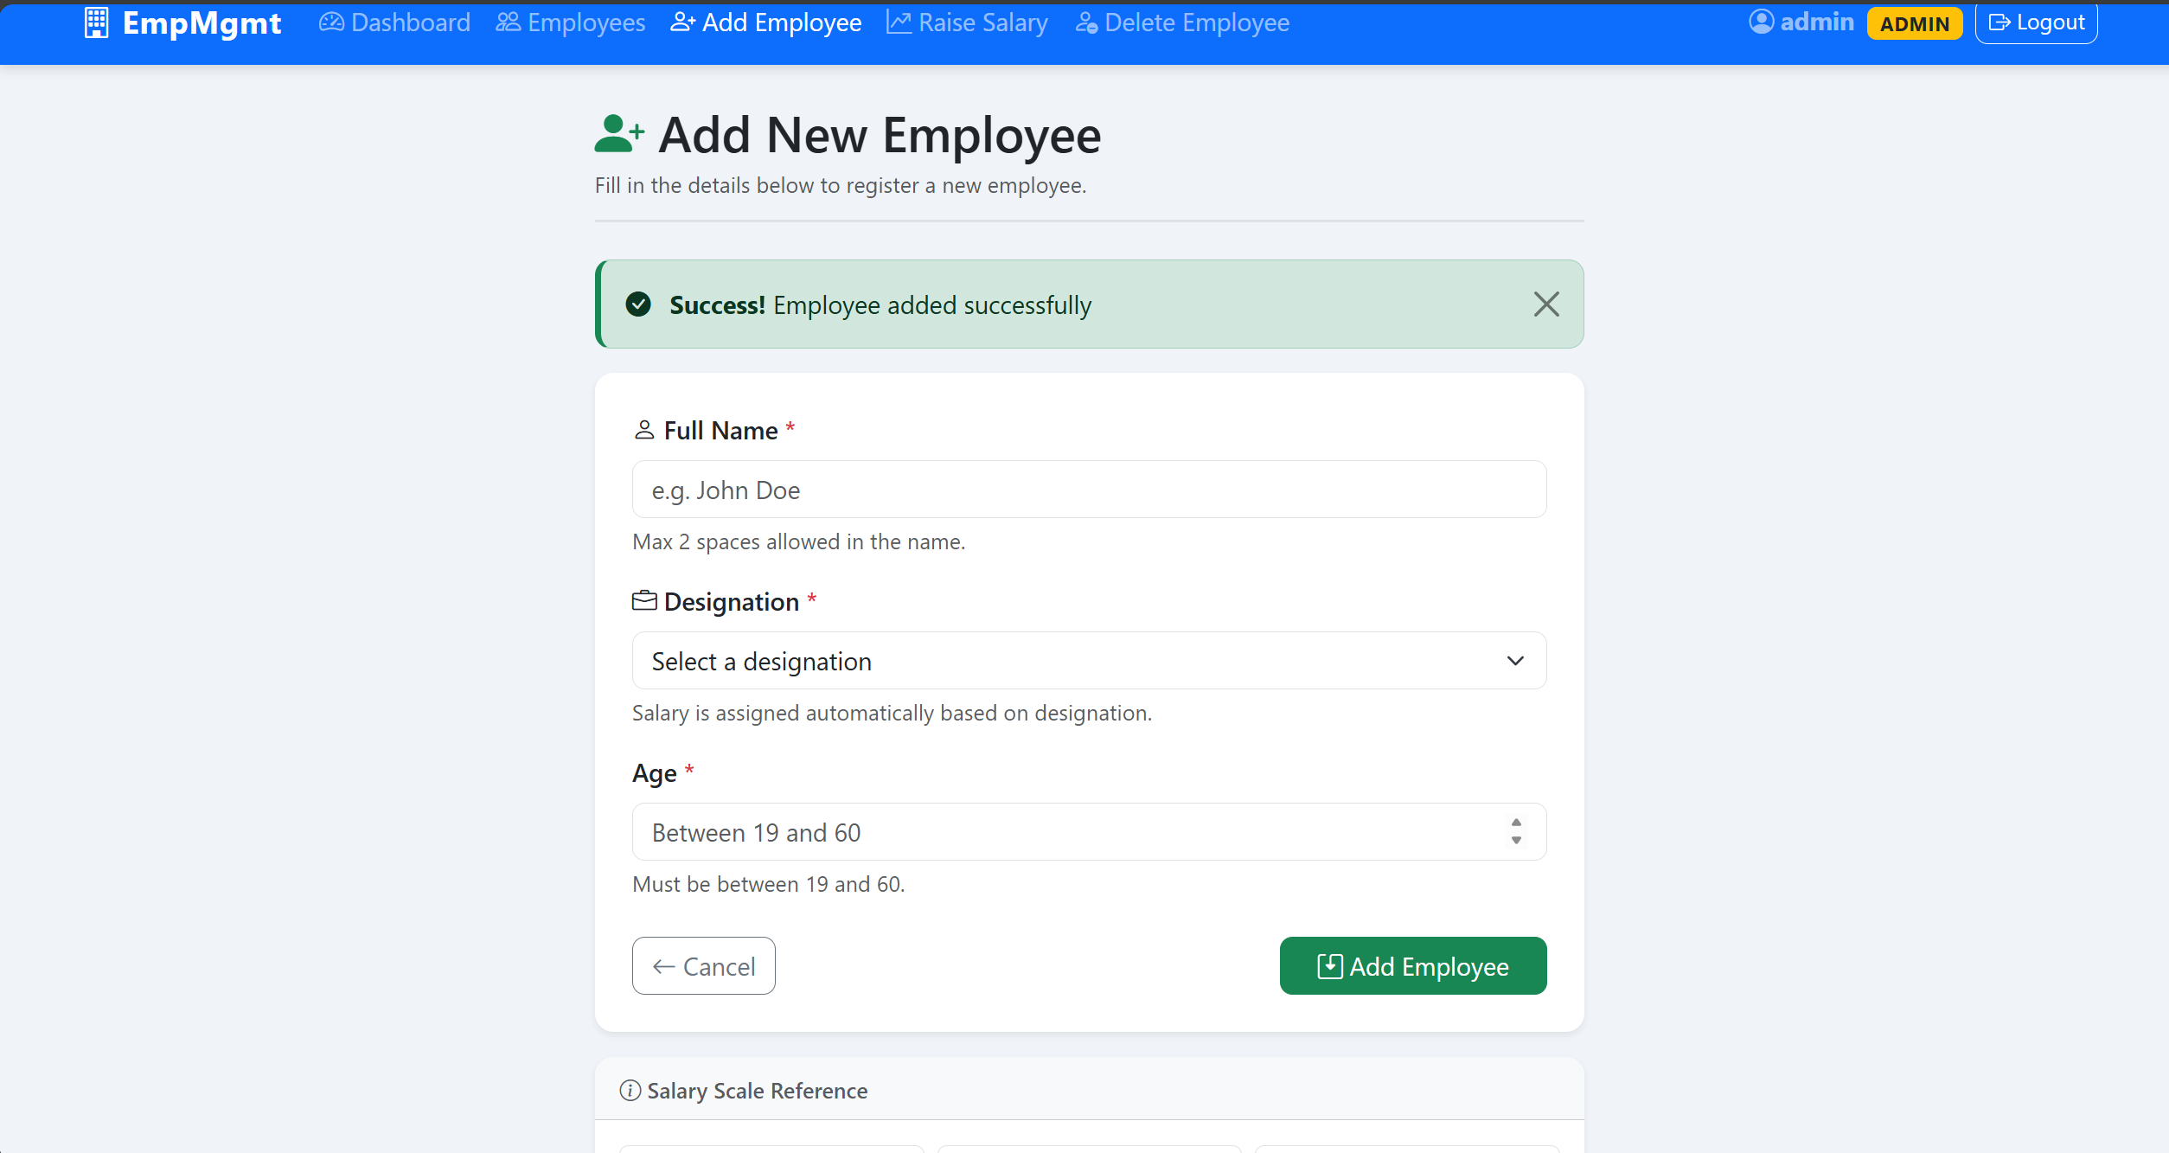
GREEN SUCCESS MESSAGE AFTER ADDING
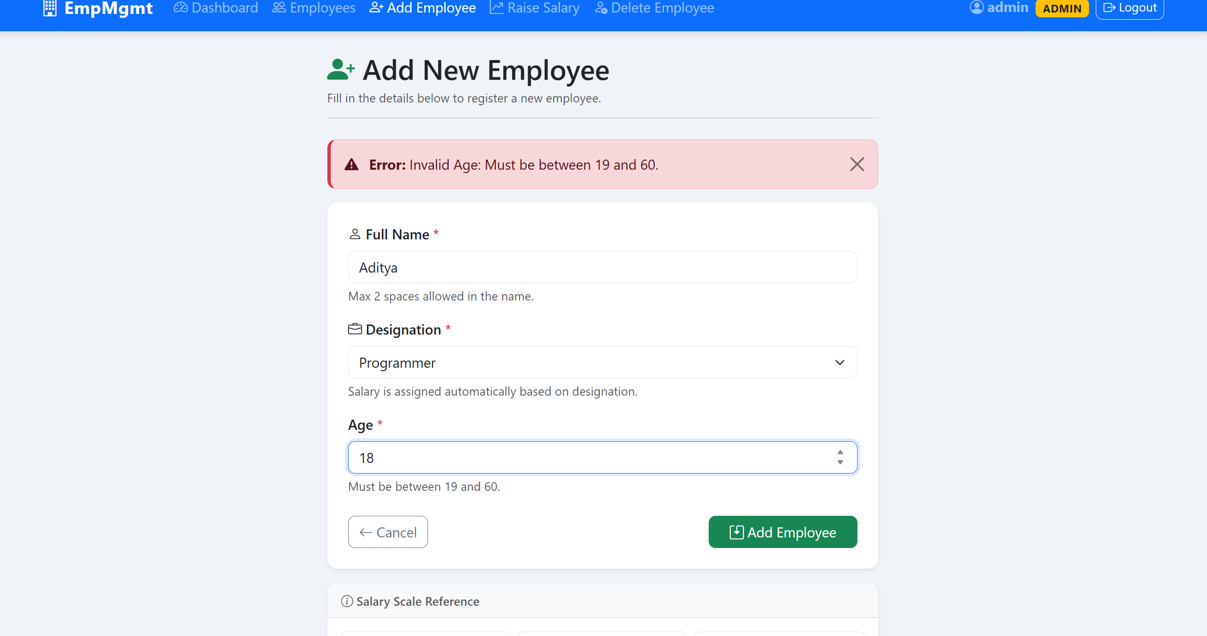
RED ERROR MESSAGE (E.G. INVALID AGE)

6. Raising a Salary (🔒 Admin only)
Click Raise Salary in the navbar or dashboard.
- Enter the employee's name.
- Use the slider to pick a percentage between 1% and 10%.
- Click Apply Raise.
Calculation formula: new salary = old salary + (old salary × percent / 100) Example: ₹20,000 with 8% raise → ₹21,600
On success you'll see the new salary in the message: "Salary updated for John Doe. New Salary: 21600"
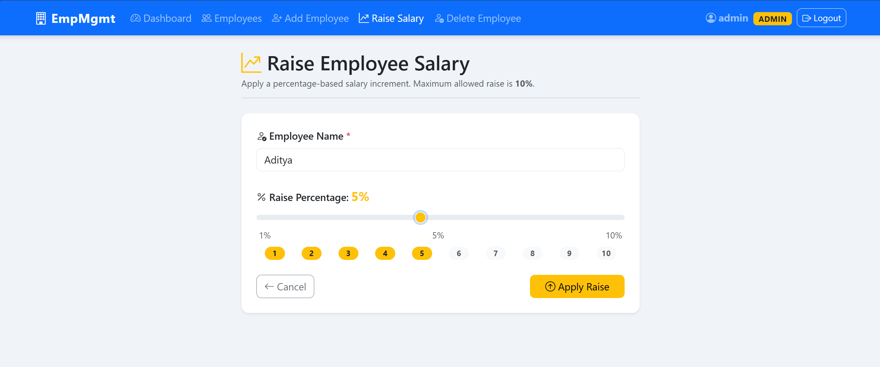
RAISE SALARY FORM WITH NAME AND SLIDER
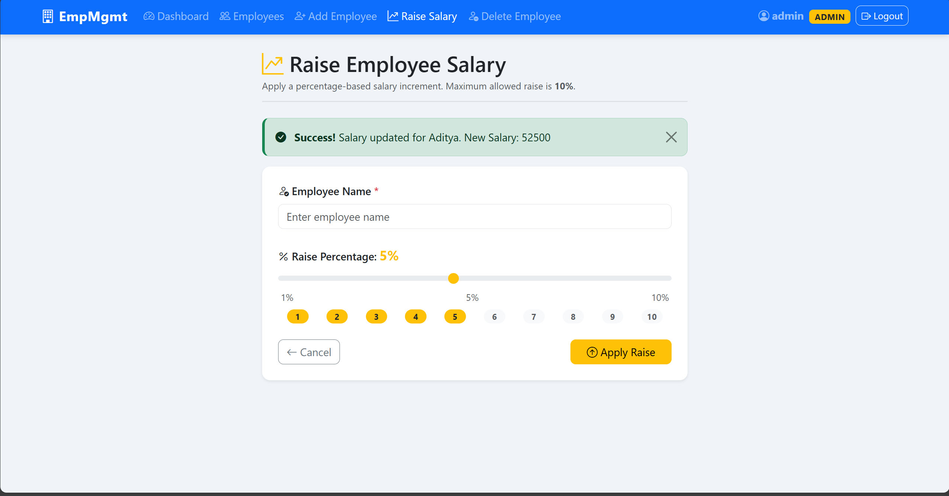
GREEN SUCCESS MESSAGE SHOWING NEW SALARY

7. Deleting an Employee (🔒 Admin only)
Click Delete Employee in the navbar or dashboard.
- Enter the employee's name.
- Click Delete Employee.
- A confirmation popup appears — click Yes, Delete to confirm.
⚠️ Warning: This is permanent and cannot be undone.
On success: "Employee John Doe deleted successfully."
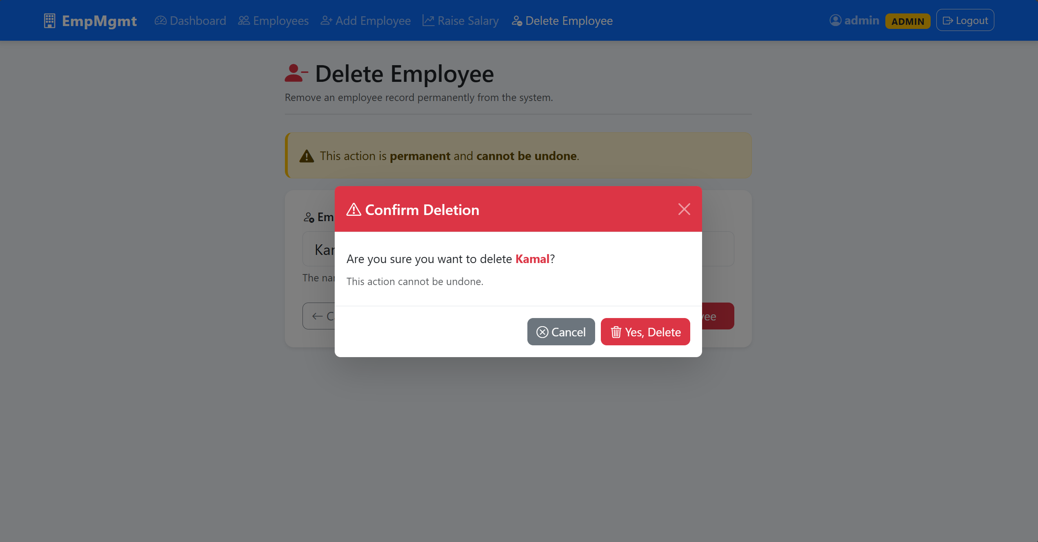
CONFIRMATION MODAL POPUP
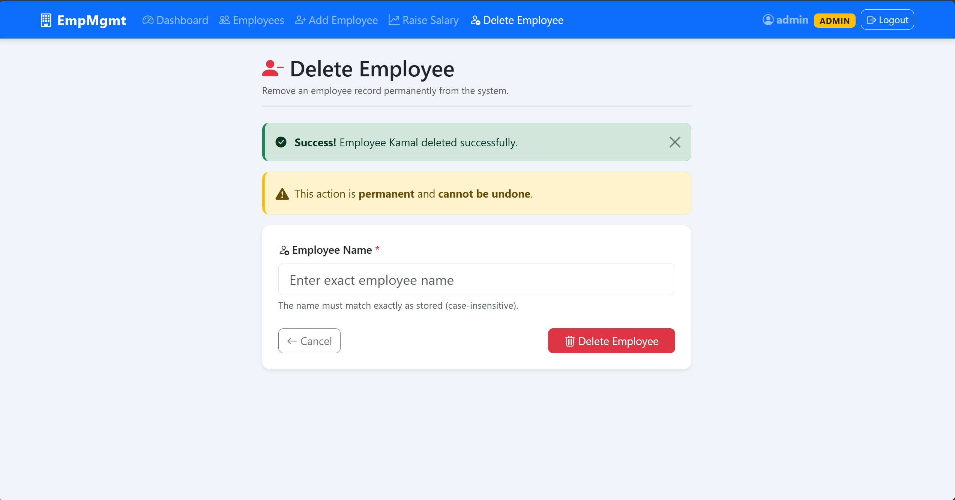
GREEN SUCCESS MESSAGE AFTER DELETION

8. Validation Rules
The server checks these rules before saving anything. If a rule is broken, a red error message is shown.
8.1 Adding an Employee
Field | Rule | Example
Name | Max 2 spaces (max 3 words) | John Doe ✅ Too Many Words Here ❌
Age | Must be 19 to 60 | 25 ✅ 15 ❌ 70 ❌
Designation | Only Programmer, Tester, or Manager | Tester ✅ Developer ❌

8.2 Raising a Salary
Field | Rule
Percent | Must be between 1% and 10%
Name | Must match an existing employee
Note: Names are matched case-insensitively — john doe will find John Doe.

9. Error Messages
Message | What it means
Invalid Name: Max 2 spaces allowed. | The name has more than 3 words
Invalid Age: Must be between 19 and 60. | Age is outside the allowed range
Invalid Designation Entered. | Designation is not Programmer, Tester, or Manager
Max Allowed Raise is 10%. | Raise percentage was below 1 or above 10
Employee not found. | No employee exists with that name
Unauthorized | Wrong username or password
Forbidden | Your role doesn't have permission for this action

10. API Endpoints
You can also call the API directly (e.g. with Hoppscotch). All requests need a username and password using Basic Auth.
Method | URL | Who can use it | What it does
GET | /employees | Everyone | Get all employees
POST | /employees | Admin | Add a new employee
PUT | /employees/raise | Admin | Raise an employee's salary
DELETE | /employees/{name} | Admin | Delete an employee by name
Example — Add Employee (JSON Request):
{
"name": "Alice Roy",
"designation": "Tester",
"age": 24
}

11. Quick Reference
- App URL: http://localhost:8080
- Database: mysql://localhost:3306/employee_mgmt
- Admin login: admin / admin123
- User login: user / user123
- Salary rates: Programmer ₹20,000 | Tester ₹15,000 | Manager ₹50,000
- Age range: 19 – 60
- Name limit: max 3 words
- Raise limit: 1% – 10%

